Practice Quiz: Protein Synthesis - KEY

Biology AP

1.
3'- cctcaaatcactctCCAGTTAGAacgacccttagtcacagtaagaatagggggacagatCCtagaATATTAagccctat -
5'- GGAgtttagtgagaGGTCAATCTtgctgggaatcagtgtcattcttatccccctgtctaGGatctTATAATtcgggata -

- tagacacaggagCGTTGgaCacagtaCCgaaTaCGtaagtttaccaggaagatggaagccaatcatgatagggggaatt –5
- atctgtgtcctcGCAACctGtgtcatGGcttAtGCatTcaaatggtccttctaccttcggttagtactatcccccttaa –3

a) Bold italicized above (5'- GGNCAATCT -3' and 5'- TATAAT -3')
b) see above (arrow)
c) The +1 position is either the C or A (big, italicized letters)
d) CAACC or AACCU
e) Met- Ala- Tyr- Ala
f) If this sequence were deleted, then the promoter regions would no longer be appropriately spaced apart, so the RNA Polymerase wouldn't bind here and this gene would not be transcribed.
g) a stop codon would be introduced—translation would stop too early. Incomplete protein made
h) RNA Polymerase reaches a termination signal.

2. There is NOT a guarantee of loss of protein function. The mutation may not cause a change in the amino acid that is coded for (because many codons can code for the same amino acid). If there is a different amino acid that is coded for, it may not change the overall protein structure that much, though, which would keep its function.

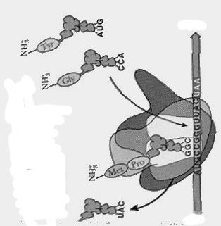
3.
A site
3’
5’
a) in diagram
b) in diagram.
c) in diagram
d) in diagram.
e) peptide bond
f) it will go get another amino acid attached to it.

4. b

5. b

6. a

7. a (you don’t need to know all of this for your quiz—just the material up to page 41 in the notes)
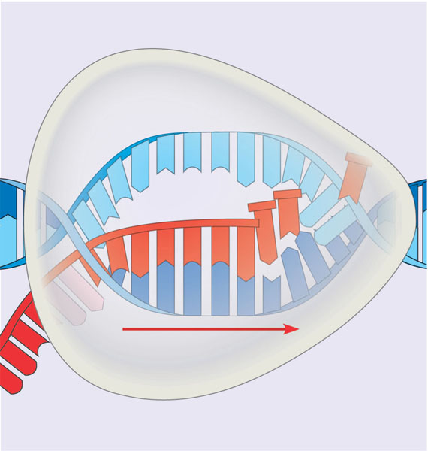
Strand A
Strand B
Direction of transcription
Strand C
8. AGCUCCA

9.
anticodon
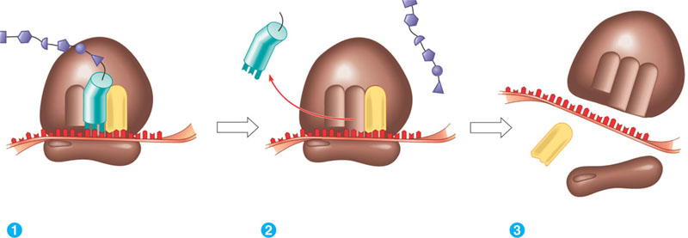
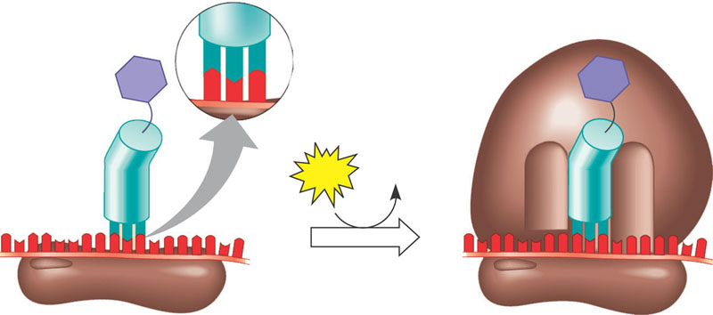
Amino acid

ribosome

mRNA

tRNA
polypeptide

Release factor

10.
RNA Splicing results in the removal of introns from pre-mRNA. The exons are kept and joined together, to create the final mRNA. A poly A tail and 5’ G cap are added to the two ends of the mRNA. This collective process of splicing and adding is called RNA Processing.
11.
a) Signal Sequence
b) Cytoplasm

12.
5-CTTGACACCGGATGCTTCCGGCTTCCCTATAATCGTATAGTGATTATGCCGTACCGTACG-3
3-GAACTGTGGCCTACGAAGGCCGAAGGGATATTAGCATATCACTAATACGGCATGGCATGC-5

a) The RNA polymerase will be chemically attracted to the -10 and -35 regions. It will bind to these regions if they are spaced out appropriately.
b) Bold italicized above (5-TTGACA-3 and 5-TATAAT-3)
c) The +1 position is either the G or T (big, italicized letters)
d) RNA Polymerase will transcribe from left to right
d) GUGAU or UGAUU
e) Methionine - Proline – Tyrosine

13. mRNA- translated into protein, tRNA- brings amino acids to the mRNA, rRNA- makes up part of the ribosome.
14.
5'-------------------------------------template----------------------------------------------------------------------------------3'
3' termination sequence-----------stop-----------coding---------start--------+1------------ -10 ---------- -35----------5'

15. a) Translation
b) It would prevent tRNA anticodons from binding to mRNA codons.
c) In addition, the microRNAs can also cause the RNA-RNA complex to be degraded by enzymes.

